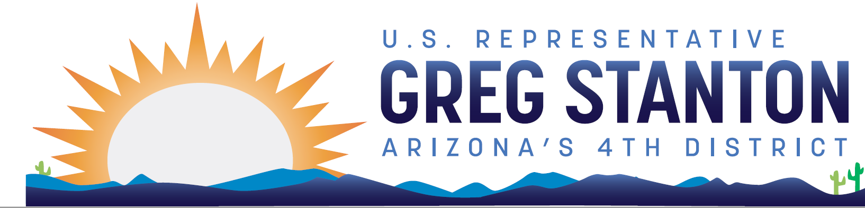
FY2025 Energy and Water Appropriations
Community Project Request Form
Return completed form and required documentation to: Appropriations.AZ04@mail.house.gov
Due Date: Monday, April 29 at 9pm AZ time

Note: The Subcommittee will only accept requests for authorized projects under the following programs: Army Corps of Engineers – Investigation, Construction, and Operations and Maintenance; Bureau of Reclamation – Water and Related Resources. Projects authorized under sections 4007, 4009(a), and 4009(c) of the Water Infrastructure Improvements Act for the Nation (WIIN) Act of 2016 (Public Law 114–322) will not be accepted. If you have questions about the appropriations project review process, please contact Alicia.Bissonnette@mail.house.gov. For further reference, see the committee website.

Non-federal Project Sponsor Requesting Funds:

Primary Point of Contact (name, email, phone number, organization address):

Project Priority (if non-federal sponsor is submitting more than 1 project):

Name of Authorized Project:

Complete Description of Project (limit 1000 characters, including spaces):

Has this project been submitted to any other Member of Congress, if so please list the Members’ name and a staff point-of-contact:

Provide the Public Law and section of the law that authorizes your project (example: P.L. 110–114, Section 1401):

Is this project considered a ‘new start’ by the agency?

If an existing projected, please list the sources and amounts of funding previously provided and in which fiscal year the funds were provided:

Total Project Cost (including breakdown of federal/non-federal shares):

Was this project included in the President’s FY2025 budget request, and if so, how much was requested?

Total Requested Amount for FY2025:

Can the full amount requested be reasonably obligated within 12 months of enactment?

Did this project receive funds in FY2024? If yes, how much and from what source?

Can the project obligate all appropriated funds within 12 months after enactment?

Has this request been submitted to any other Subcommittee this year, and if yes, which ones and by whom?

Estimated Start Date:

Estimated Completion Date:

Is the funding requested by a governmental or non-profit organization?

Attach a letter of support from the non-federal sponsor of the project or the project partner for the project being requested. If there is no official non-federal sponsor or project partner, this can be a letter of support from the community or city/county.

Why this project is a community priority?

Recipient Point of Contact – please include contact information for the relevant Corps District Project Manager and Corps District name (i.e. Jane Doe, Los Angeles District) or the relevant Reclamation staff name and Region name (i.e. John Doe, California Great Basin Region). For us, that’s the Lower Colorado River Basin for the Bureau.

Recipient Phone Number – please include the Point of Contact’s cell phone number

Recipient Email Address – please include the Point of Contact’s email address

Recipient Address – please enter the street address for the Army Corps/Bureau of Reclamation Point of Contact

In which Congressional district(s) is the project located?

Project Address (if different from Recipient)

Please indicate if this is a Corps request for an authorized Environmental Infrastructure project.

Please indicate if this is a Corps request for a Continuing Authorities Program (CAP) project.

If making a Corps request, please provide the name of the Corps Division where the project is located. If it is not a Corps request, write N/A.

Please provide the name of the Corps District where the project is located.

If making a Reclamation request, please provide the name of the Reclamation Region where the project is located.

