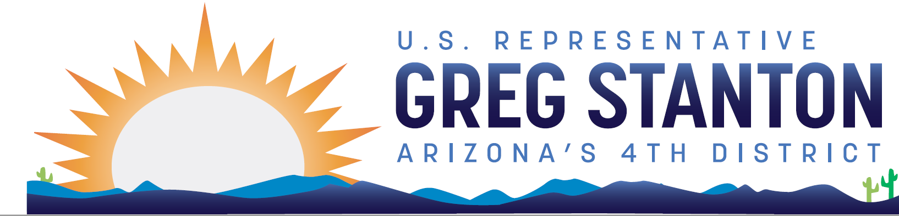

FY2025 Interior and Environment Appropriations
Community Project Request Form
Return completed form and required documentation to: Appropriatons.AZ04@mail.house.gov
Due Date: Monday, April 29 at 9pm AZ time

Note: Only certain entities are eligible to request projects. Projects cannot be designated for private individuals or for-profit entities. The Subcommittee will only accept legally eligible requests under the following account: Environmental Protection Agency State and Tribal Assistance. If you have questions about the appropriations project review process, please contact Alicia.Bissonnette@mail.house.gov. For further reference, see the committee website.

Entity Requesting Funds (legal name, no abbreviations):

If this entity is a non-profit, please include documentation that the entity is a registered 501(c)(3) under the Internal Revenue Code of 1986.

Primary Point of Contact (name, email, phone number, address):

Project Priority (if non-federal sponsor is submitting more than 1 project):

Project description:

Amount of CPF funding requested for the project:

Total project cost:

Can the project obligate all of the appropriated funds within 12 months after enactment (yes/no)?

Estimated start and completion dates for the project.

Include an explanation of why the project is a good use of taxpayer funds.

Has this request been submitted to another Member, if yes, which Member(s) and who is the staff point-of-contact?

Demonstration of community support for a project is crucial for determining whether it should receive funding. Projects must have substantial evidence of community support to be considered for funding. Community support documentation can include: letters from elected officials and community groups, local transportation or community development plans, publications (including news articles), and any other documents demonstrating public support for the project. Please include documentation of community support in one pdf document and submit with this form.

Environmental Protection Agency, State and Tribal Assistance Grants, Clean Water/Drinking Water infrastructure projects

Is this a Clean Water SRF project or a Drinking Water SRF project?

Is the project on your State’s most recently finalized Clean Water/Drinking Water SRF
Intended Use Plan (IUP)?

Has the project received Federal funds previously? If so, please describe.

Does the project have (or expects to have within 12 months) its 20% cost share requirement?

Given the Federal nexus requirement, does the project help meet or maintain Clean Water
Act/Safe Drinking Water Act standards? If so, please describe.

Each of these projects must have a federal nexus. Projects that do not have a nexus will not be considered.

The project has a Federal nexus because the funding provided is for purposes authorized by Title VI of the Clean Water Act, 33 U.S.C 1381 et seq. [Clean Water Projects] OR Section 1452 of the Safe Drinking Water Act, 42 U.S.C. 300j-12. [Drinking Water Projects].

