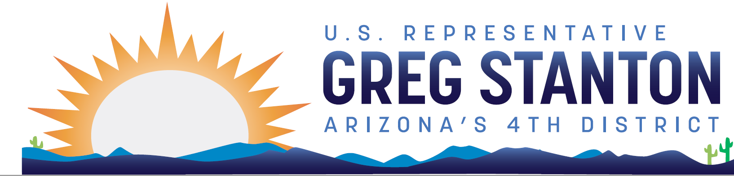
FY2025 Commerce, Justice, Science Appropriations
Community Project Request Form
Return completed form and required documentation to: Appropriations.AZ04@mail.house.gov
Due Date: Monday, April 29 at 9pm AZ time

Note: Only certain entities are eligible to request projects. Projects cannot be designated for private individuals or for-profit entities. The Subcommittee will only accept legally eligible requests under the following accounts: Byrne Justice Assistance Grants; COPS Technology and Equipment; National Oceanic and Atmospheric Administration—Coastal Zone Management; National Aeronautics and Space Administration--Safety, Security and Mission Services; and National Institute of Standards and Technology–Scientific and Technical Research Services.

To be considered, the project must be legally eligible for grants under these accounts and comply with all applicable laws, rules, and regulations related to the specific grant program. If you have questions about the appropriations project review process, please contact Alicia.Bissonnette@mail.house.gov. For further reference, see the committee website. Incomplete project requests will not be considered by the Committee.

Entity Requesting Funds (legal name of the non-federal project sponsor, no abbreviations; non-profits must attach evidence that the organization is a registered non-profit under section 501(c)(3) of the Internal Revenue Code of 1986):

Primary Point of Contact (name, email, phone number, organization address):

Project Priority (if submitting more than 1 project):

Legally Eligible Account for Project Request (Byrne JAG, COPS T&E, NOAA-CZM, NASA SSMS, NIST STRS):

Complete Description of Project, including goals and objectives:

Amount of CPF funding requested for the project:

Total project cost:

Can this project spend a smaller amount of appropriated funds within 12 months of the enactment of the appropriations act? [yes/no] If yes, please provide any details that may be helpful for understanding the scalability of the project.

Are you aware of another Member making a request for this same project?

Please provide the location of this project, in the format ‘City (or County), State’.

Is the purpose of this request the construction or renovation of a building?

Has this same project request been submitted to another Appropriations subcommittee? If yes, which one?

Supplemental Questions for Byrne Justice Grants project requests:
- Is the recipient entity a non-profit organization as described under section 501(c)(3) of the Internal Revenue Code of 1986? [yes/no]

- Can this project spend a smaller amount of appropriated funds within 12 months of the enactment of the appropriations act? [yes/no] If yes, please provide any details that may be helpful for understanding the scalability of the project.

- Is the purpose of this request the construction or renovation of a building? [yes/no]

- Are you aware of another Member making a request for this same project? [yes/no]

- Please provide the location of this project, in the format ‘City (or County), State’.

Supplemental Questions for COPS Technology and Equipment project requests:
- Is the recipient a State, Tribal, or local law enforcement agency?

- Can this project spend a smaller amount of appropriated funds within 12 months of the enactment of the appropriations act? [yes/no] If yes, please provide any details that may be helpful for understanding the scalability of the project.

- Is the purpose of this request the construction or renovation of a building? [yes/no]

- Are you aware of another Member making a request for this same project? [yes/no] 5. Please provide the location of this project, in the format ‘City (or County), State’.

Supplemental Questions for NIST Scientific and Technical Research project requests:
- Is the recipient entity a non-profit organization as described under section 501(c)(3) of the Internal Revenue Code of 1986? [yes/no]

- Can this project spend a smaller amount of appropriated funds within 12 months of the enactment of the appropriations act? [yes/no] If yes, please provide any details that may be helpful for understanding the scalability of the project.

- Are you aware of another Member making a request for this same project?

- Please provide the location of this project, in the format ‘City (or County), State’.

Supplemental Questions for NOAA Coastal Zone Management project requests:
- Is the recipient entity a non-profit organization as described under section 501(c)(3) of the Internal Revenue Code of 1986? [yes/no]

- Can this project spend a smaller amount of appropriated funds within 12 months of the enactment of the appropriations act? [yes/no] If yes, please provide any details that may be helpful for understanding the scalability of the project.

- Are you aware of another Member making a request for this same project? 4. Please provide the location of this project, in the format ‘City (or County), State’.

Supplemental Questions for NASA Safety, Security, and Mission Services project requests:
- Is the recipient entity a non-profit organization as described under section 501(c)(3) of the Internal Revenue Code of 1986? [yes/no]

- Can this project spend a smaller amount of appropriated funds within 12 months of the enactment of the appropriations act? [yes/no] If yes, please provide any details that may be helpful for understanding the scalability of the project.

- Is the purpose of this request the construction or renovation of a building? [yes/no]

- Are you aware of another Member making a request for this same project? [yes/no]

- Please provide the location of this project, in the format ‘City (or County), State’.

Demonstration of community support for a project is crucial for determining whether it should receive funding. Projects must have substantial evidence of community support to be considered for funding. Community support documentation can include: letters from elected officials and community groups, local transportation or community development plans, publications (including news articles), and any other documents demonstrating public support for the project. Please include documentation of community support in one pdf document and submit with this form.

Each of these projects must have a federal nexus. Projects that do not have a nexus will not be considered.
- section 272 of title 15, United States Code. [for NIST Scientific and Technical Research projects]
- the Coastal Zone Management Act of 1972 (16 U.S.C. § 1451 et seq.). [for NOAA Coastal Zone Management projects]
- section 501 of the Omnibus Crime Control and Safe Streets Act of 1968 (34 U.S.C. § 10152). [for DOJ Byrne Justice Grants projects]
- section 1701(b)(8) of the Omnibus Crime Control and Safe Streets Act of 1968 (34 U.S.C. § 10381(b)(8)). [for DOJ COPS Technology and Equipment projects]
- section 20102 of title 51, United States Code. [for NASA Safety, Security, and Mission Services projects]

