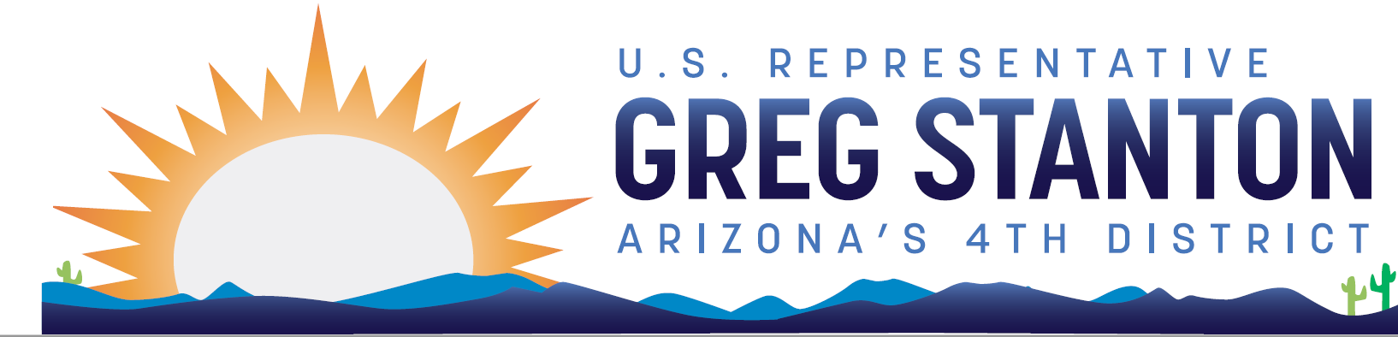
FY2025 Agriculture Appropriations
Community Project Request Form
Return completed form and required documentation to: Appropriations.AZ04@mail.house.gov
Due Date: Monday, April 29 at 9pm AZ time

Note: Only certain entities are eligible to request projects. Projects cannot be designated for private individuals or for-profit entities. The Subcommittee will only accept legally eligible requests under the following accounts: Agricultural Research Service, Buildings and Facilities; Rural Development, Rural Community Facility Grants; Rural Utilities Service, ReConnect Grants; Rural Utilities Service, District Learning and Telemedicine Grants; Rural Utilities Service, Water and Waste Grants; and Natural Resources Conservation Service, Conservation Operations. If you have questions about the appropriations project review process, please contact Alicia.Bissonnette@mail.house.gov. For further reference, see the committee website.

Entity Requesting Funds (aka non-federal project sponsor):

Primary Point of Contact (name, email, phone number, organization address):

Project Priority (if non-federal sponsor is submitting more than 1 project):

Short description of the project to appear in the report:

Total Project Cost (including breakdown of federal/non-federal shares):

Amount of CPF funding requested for the project:

Sources of funding for the full share of the cost of the project if amount received is less than amount requested:

Whether the project has received Federal funding previously, and if so, the source and amount:

Complete Description of Project (limit 1000 characters, including spaces):

The website address of the proposed recipient:

If there are additional costs necessary to complete the project, have those been secured?

For rural development projects, is the project for an eligible purpose and does it meet all eligibility requirements under current law (Explain how it meets those requirements)?

Does the entity plan to make grants to other entities from the funds provided and if so, to which entities?

Why is the project a priority the community? Briefly explain the community benefits.

Has any funding for the project been included in any presidential budget and if so, how much, in which fiscal year, and in which agency or agencies and program(s)?

Has the project received federal funding before and if so, how much, when, and from which agency or agencies and program(s)?

Have you contacted the State Rural Development Office/State Conservation Office to discuss the project and confirm eligibility?

For ARS B&F only, is it an existing USDA owned and operated facility? (It must be,
in order to be eligible.)

For ARS B&F only, what is the estimated start date of the project? How soon could the
feasibility/engineering design phase commence? [mm/yy]

For ARS B&F only, does the project have distinct and separable phases?

For ARS B&F only, what is the estimated completion date of the project? When does completion
of construction occur? [mm/yy]

For ReConnect requests only, please provide relevant information, such as the number of households, businesses, or farms that would be served, what the performance of the service to be offered will be, and whether healthcare or educational facilities will be served.

For Conservation Operations requests only, briefly describe how the project will reduce soil erosion, enhance water supplies, improve water quality, increase wildlife habitat, or other objectives that will help conserve, maintain, and improve natural resources.

For Water and Waste requests only, provide relevant information, such as the number of
households, businesses, or farms that would be served.

Demonstration of community support for a project is crucial for determining whether it should receive funding. Projects must have substantial evidence of community support to be considered for funding. Community support documentation can include: letters from elected officials and community groups, local transportation or community development plans, publications (including news articles), and any other documents demonstrating public support for the project. Please include documentation of community support in one pdf document and submit with this form.

Each of these projects must have a federal nexus. Projects that do not have a nexus will not be considered.

Agricultural Research Service, Buildings and Facilities
- This project has a Federal nexus because it is for the purposes authorized in 7 U.S. Code section 2250.
Natural Resources Conservation Service, Conservation Operations
- This project has a Federal nexus because it is for the purposes authorized by the Soil Conservation and Allotment Domestic Act of 1935, 16 U.S. Code sections 590a-590d and 590f-g.
Rural Development, Rural Housing Service, Community Facilities Grants
- This project has a Federal nexus because it is for the purposes authorized in Section 306 of the Consolidated Farm and Rural Development Act, 7 U.S. Code section 1926(a).
Rural Development, Rural Utilities Service, ReConnect Grants
- This project has a Federal nexus as it is for the same purposes authorized in the pilot program established by section 779 of division A of the Consolidated Appropriations Act, 2018 (Public Law 115–141).
Rural Development, Rural Utilities Service, Water and Waste Grants
- This project has a Federal nexus because it is for the purposes authorized in Section 306 of the Consolidated Farm and Rural Development Act, 7 U.S. Code section 1926(a)(2).
Rural Development, Rural Utilities Service, Distance Learning and Telemedicine Grants
- This project has a Federal nexus because it is for the purposes authorized in Section 2331 of the Food, Agriculture, Conservation, and Trade Act of 1990, 7 U.S. Code section 950aaa.

