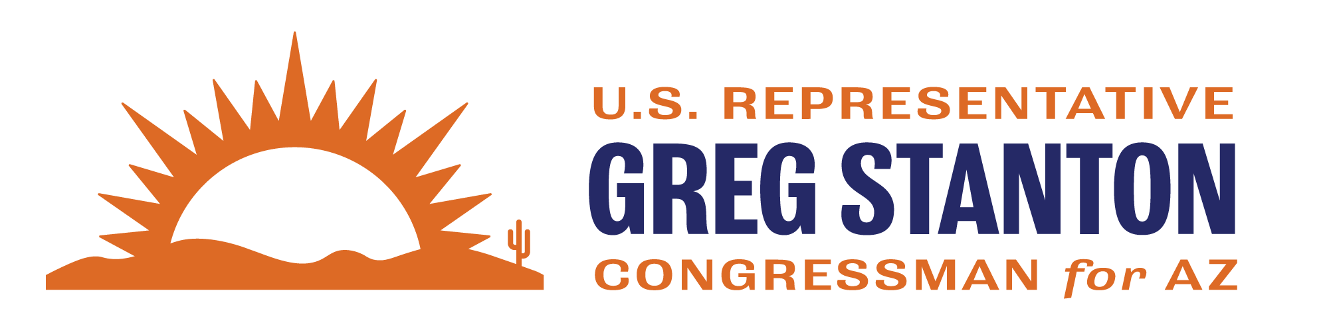

FY2027 Labor-Health and Human Services-Education Appropriations Community Project Request Form
Return completed form and required documentation to: Appropriations.AZ04@mail.house.gov
Due Date: FRIDAY, MARCH 6 at 11:59pm

Note: The Subcommittee will only accept requests for projects in the following accounts:
- HHS – Health Resources and Services Administration - HRSA-Wide Activities and Program Support - Health Facilities Construction and Equipment

If you have questions about the appropriations project review process, please contact Appropriations.AZ04@mail.house.gov. For further reference, see the committee website.

Non-federal Project Sponsor Requesting Funds:

Primary Point of Contact (name, email, phone number, organization address):

Project Priority (if non-federal sponsor is submitting more than 1 project):

Why is this project important for the community:

Has this project been submitted to any other Member of Congress, if so please list the Members’ name and a staff point-of-contact:

Is the entity to receive the funds a non-profit? If yes, provide documentation that the non-profit is a 501(c)3:

Has the project received federal funding before and, if so, how much, when and from which agencies and program(s)?

What is the Employer Identification Number (EIN) for the recipient organization?

Please provide a budget breakdown of this project – maximum of 10 budget categories (i.e., do not upload a spreadsheet with dozens of budget items).

Please provide the website of the entity to receive funding for this project. (7) If the request does not fully fund the project, describe the source(s) of funding necessary to complete the project.

Demonstration of community support for a project is crucial for determining whether it should receive funding. Projects must have substantial evidence of community support to be considered for funding. Community support documentation can include: letters from elected officials and community groups, local transportation or community development plans, publications (including news articles), and any other documents demonstrating public support for the project. Please include documentation of community support in one pdf document and submit with this form.

Amount of CPF funding requested for the project:

